www.marjenes.com.au

2019 Full Day Course in Infection Prevention & Control to all General Practice staff
McLaren Vale SA - Thursday April 11th 9am - 5pm at Wirra Wirra winery, 255 Strout Rd., McLaren Vale, SA

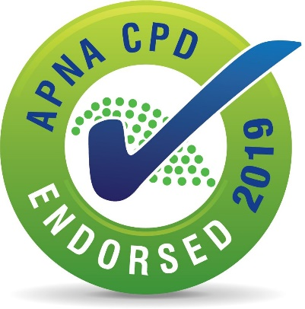

“This activity has been endorsed by APNA according to approved quality standards criteria.”

This day session has been allocated 8 CPD hrs and assists achieve reaccreditation requirements in Infection Control
Features
- Maximum of 10 - 14 nurses/managers/receptionists to enhance the competency checking experience.
- Fee includes materials & folder, a complimentary copy of my new 2019 prac guide and cleaning policy template
- Fee includes Tea/Coffee on arrival, morning tea, single course lunch with wine, fruit, dietary reqs included
- No deposit or prepay - 14 day invoice sent after course. NB 25% cancellation fee for confirmed bookings
- Fee is $330 pp or $605 for two colleagues same practice, $275 for non-working attendee
- Reg. 8.45am with coffee, session starts 9am. If you do not do instrument processing, you may leave at 4 (7 CPD)
Topics
- Triage for suspect flu/gastro/measles, Precautions, Staff Immunisation, Clinical Waste, Sharps Injury (2 hrs)
- Competency checking for; Hand hygiene, use of pandemic PPE, cleaning, managing body fluid spills (2 hrs)
- Infection Control for wound care i.e. best practice for hand hygiene, glove changes, cleaning (15 minutes)
- Managing hand hygiene and surface disinfection for pts with Multiresistant Organisms e.g. MRSA (15 minutes)
- Instrument processing (Last 2 hours or 1 hr if you do not perform instrument sterilisation at work - 7 APNA CPD)
---------------------------------------------------------------------------------------------------------------------------------

Complete details below for each attendee. Email marjenes@optusnet.com.au or fax 03 9439 2436

1. Your name as you want it printed on your certificate………..

2. Your mobile contact details prior to and on the day…….

3. Best accessible (including AH) email address for notes and communication in the weeks prior to the session

4. Are you leaving early at 4pm? (highlight or circle) YES / NO.

5. Do you have any dietary requirements - ………..

6. Indicate the name and email address of the person receiving the electronic invoice after the course

I will confirm your booking as soon as I receive this completed form.

Margaret Jennings (Mobile 0404 088 754),
Microbiologist and Infection Prevention & Control Educator/Consultant to Office Based Practice

